Balance Assessment Practical
Learning Outcomes
By the end of this practical students should be able to:
- Conduct a balance assessment in sitting and standing
- Conduct impairments’ assessments associated with balance deficit
- Practice common clinical outcome measures for balance.
Introduction
Balance assessment should be performed in the context of a functional activity – bed mobility, sitting, standing, walking. Three things to consider:
- Patient Safety
- Quantifying functional limitations
- Identify underlying impairments

- Sitting balance assessment (25 minutes)
- Safety considerations: stable bed, feet touching the floor to provide stability, risk assessment – task, individual capacity, load, and environment
- Dressing: The patient’s trunk should be undressed but dignity must always be maintained.
- Start with posture - Observe alignment of all the body segments - head and neck, trunk, scapula, upper limb, pelvis and lower limb - from the front, behind and side.
- Observation: Look for each segment’s orientation and deviation from normal
- Palpation: Look for clues by observing or palpating
  - Skin crease, bony points, joint lines, weight bearing status, adjacent muscle activity
- Describe what you see in the case note – see example.
- Static balance Time: How long can patient maintain in an unsupported sitting position?

- Dynamic Balance during movement:
  - Can patient:
    - clasp their hands together and lean down to the floor on the non-affected, between the feet and to the affected side?
    - Reach over to the weak side or the unaffected side – moving the trunk over the pelvis, and towards the affected side?
    - Reach to the side with reduced base of support – leg crossed, decrease the base of support by moving the bottom towards the edge of the plinth or feet raised from the floor
    - Rotate the trunk to one side (therapists blocks the lower limb on the side patient is rotating to).

- Sitting balance strategy
  - Patient sits on a plinth with both feet touching the floor
  - Instruct patient to slightly shift weight to the side:
    - Trunk curves towards unweighted side
  - Instruct patient to shift more weight to one side
    - Trunk curves and abduction of arm and leg on the unweighted side
  - Instruct patient to shift more weight to the side
    - The arm is extended on the side patient is moving to to maintain balance.

- Standing Balance assessment (30 minutes)
- Safety considerations: standing at a corner, between parallel bars, behind a stable bed or plinth, using a balance belt; risk assessment – task, individual capacity, load, and environment.
- Dressing: Patient stand with trunk undressed but dignity must always be maintained, appropriate shoes - trainers or bare feet.
- Start with Posture (static balance)
  - Observe patient standing with feet shoulder width apart with eyes open (Time) – (Timed Unsupported Stand of TUSS)
- Standing balance (dynamic balance)
  - Observe patient standing with increasing movements of different body parts e.g.
    - Eyes, head, trunk, arms and knees bending - look up and down, look to the left and right side with the trunk and arms, and knees bending (picking up an object)
  - Observe the patient doing these tasks with eyes closed

- Assessment of Strategy – Movement strategies
  - Assess lower limb muscle strength and range of movement:
    - Ankle muscles
    - Knee muscles
    - Hip muscles
  - Assessment of postural symmetry
    - Use two weighting scales to assess proportion of weight on either limb
  - Ankle Strategy
    - Self-initiated: patient is instructed to shift weight slightly forward slowly.
    - Response to perturbation: hold the patient by the hips, and displace the hips forwards and backwards
      - For forward sway: activation of the calf, hamstrings and paraspinal muscles
      - For backward sway: activation of the ankle dorsiflexors, quadriceps and abdominal muscles.
  - Hip Strategy
    - Self-initiated: With the patient in tandem standing, instruct patient to sway forward as far as they can without taking a step.
    - Response to perturbation: With the patient in tandem standing, hold the patient by the hips, displace the hips forwards and backwards as quickly as you can.
      - For forward sway: activation of abdominal and quadriceps muscles
      - For backward sway: activation of the paraspinal and quadriceps muscles.
  - Stepping strategy
    - Self-initiated: patient is instructed to lean forward as far as possible on the therapist’s hand and the hand is released unexpectedly
    - Response to perturbation: hold the patient by the hips and displace the hips forwards and backwards as quickly as possible.
      - Forward perturbation: forward step
      - Backward perturbation: backward step
- Sensory Strategy: Modified Clinical Test for Sensory Integration In Balance (15 minutes)
The purpose of the test is to assess how well an individual is using sensory inputs when one or more sensory inputs are compromised. This test provides some insight into whether each of the sensory system available for balance are being used effectively.
Starts timing, and stop if patient open eyes in an eyes closed condition, raised arms or loses balance or require assistance
Conditions 1 | Eyes Open, Firm Surface
 | Trial 1 | Total Time: /30
 | Trial 2 | Total Time: /30
 | Trial 3 | Total Time: /30
Condition 2 | Eyes Closed, Firm Surface
 | Trial 1 | Total Time: /30
 | Trial 2 | Total Time: /30
 | Trial 3 | Total Time: /30
Condition 3 | Eyes Open, Foam Surface
 | Trial 1 | Total Time: /30
 | Trial 2 | Total Time: /30
 | Trial 3 | Total Time: /30
Condition 4 | Eyes Open, Foam Surface
 | Trial 1 | Total Time: /30
 | Trial 2 | Total Time: /30
 | Trial 3 | Total Time: /30
 |  | Total: /120

Interpretation
 | What is happening | Interpretation
Condition 1 | Visual, somatosensory and vestibular available | All systems being used
Condition 2 | Visual unavailable | Visually dependent
Condition 3 | Somatosensory compromised | Surface dependent (vestibular and visual not used effectively)
Condition 4 | Visual & somatosensory compromised | Vestibular not being used effectively
OUTCOME MEASURES (20 minutes)
- Mini BesTest
Use the templates on the nest page to complete this common outcome measure used in clinical practice. It assesses 6 different balance control systems that can be targeted in balance rehabilitation.
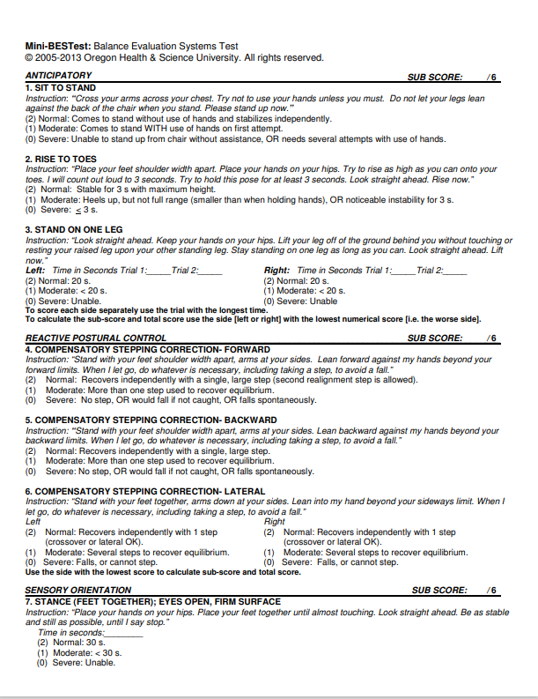

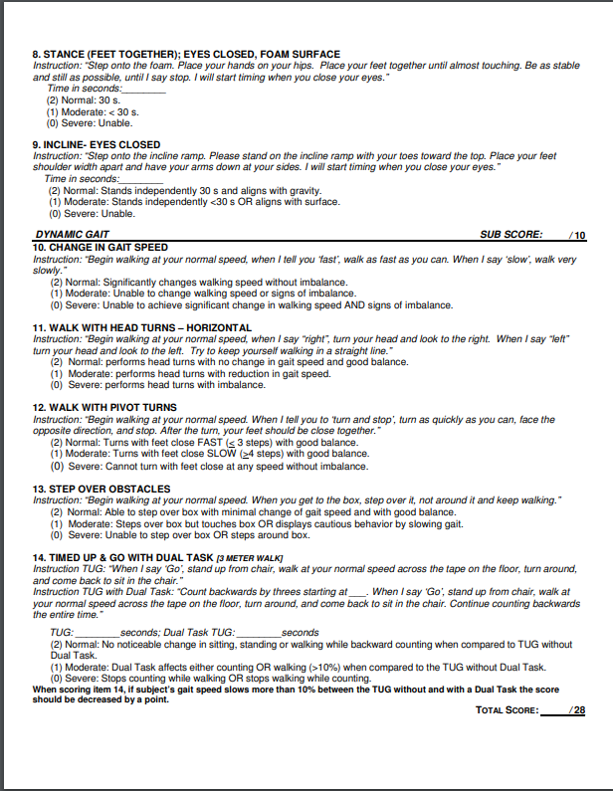

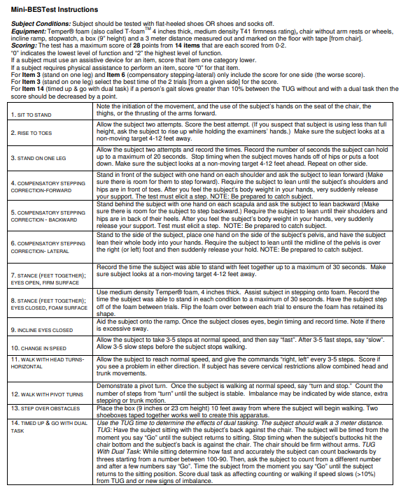
Other common Outcome measures (Self Directed Study)
- Functional Reach Test: It is a quick, single-task, dynamic test that is used to predicting falls in older adults. This test measures the margin of stability along with the ability to measure balance during a functional task.

- Timed Up and go: To determine fall risk and measure the progress of balance, sit to stand and walking. It is a simple screening test that is sensitive and specific measure of probability of falls among older adults.

- Berg Balance Scale: is used to objectively determine a patient's ability (or inability) to safely balance during a series of predetermined tasks.

- Dynamic Gait Index: The DGI tests the ability of the participant to maintain walking balance while responding to different task demands, through various dynamic conditions. It is a useful test in individuals with vestibular and balance problems and those at risk of falls.

- Functional Gait Assessment:: The Functional Gait Assessment (FGA) is a modification of the Dynamic Gait Index (DGI) that uses higher-level tasks to increase the applicability of the test to people with vestibular disorders and to eliminate the ceiling effect of the original test. Three items were added to the DGI because these were noted to be difficult in people with vestibular disorders.

- Activity Specific Balance Confidence Scale (ABC): Activities-specific balance confidence (ABC) scale is a structured questionnaire that measures an individual’s confidence during ambulatory activities without falling or experiencing a sense of unsteadiness.

